

**Department of Information Science and Engineering**

**COURSE CODE: 19IS4PCJAV COURSE: JAVA PROGRAMMING**

**LAB PROGRAM LIST**

**AY – 2019-20**

1 a. Design and create a class named Retail Item that holds data about an item in a retail store. The class should have the following fields:

* Description - The description field references a String object that holds a brief description of the item.
* Units - The units field is an int variable that holds the number of units currently in inventory.
* Price - The price field is a double that holds the item’s retail price.

Write a constructor that accepts arguments for each field, appropriate mutator methods that store values in these fields, and accessor methods that return the values in these fields. Write the main method which creates three Retail Item objects and invokes appropriate methods.

1b.Write a class named Car that has the following data members:

• **model**. The model field is an int that holds the car’s year.

• **make**. The make field references a String object that holds the make of the car.

• **speed**. The speed field is an int that holds the car’s current speed.

The class should have the following constructor and other methods.

• The constructor should accept the car’s year model, make and speed as arguments.

• Accessor methods should get the values stored in an object’s year, Model, make, and speed fields.

• Accelerate method should add 5 to the speed field each time it is called.

• Brake method should subtract 5 from the speed field each time it is called.

Demonstrate the class in a program that creates a Car object, and then calls the accelerate method five times. After each call to the accelerate method, get the current speed of the car and display it. Call the brake method five times. After each call to the brake method, get the current speed of the car and display it.

2a. Identify the type of inheritance in the given diagram. Create a class A with two integer member variables that are private, two float variables that are protected and two integer variables that are public. Let class B inherit class A and class C and Class D are inherited from class B. Write appropriate methods to illustrate the following

1. Usage of super keyword
2. Function overriding
3. Default constructors
4. Parameterized constructors
5. How to we make a method not to be over ridden and a class not be inherited further

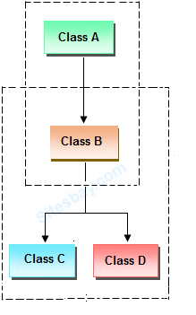

2b. Define one class **A** in package **apack**. In class **A**, four variables are defined of access modifiers default, protected, private and public. Define class **B** in package **bpack** which extends **A** and write **display()** method which access variables of class **A**. Define class **C** in package **cpack** which has one method **display()** in that create one object of class **A** and display its variables. Define class **ProtectedDemo** in package **dpack** which contains the main () method. Create objects of class **B** and **C** and call display method for both these objects. Analyze the program by interpreting the access modifiers and provide valid conclusion.

2c. Design the given model in java

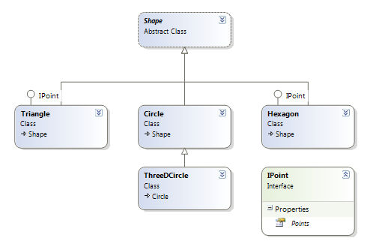

3 a. Consider a student examination database system that prints the mark sheet of the students. Input the following from the command line student name and marks in 6 subjects. These marks should be in between 0 and 50 if the marks are not in the specified range raise a Range Exception else find the total marks and print the percentage of the student.

3b. Create a class temperature with member variable temp. Implement exception handling to test if temperature is equal to zero.

4 a. Consider a Bus reservation system that allows online reservations to its customers. Suppose there are two transactions of reservation for a particular seat simultaneously which leads to race condition. Develop a solution to avoid the unpredictable situation with a program.

4 b. Create a class called Library. Write a program to manipulate the book information from files by using FileInputStream and FileOutputStream.

5 a. Write a program to implement dynamic growable queue using generics.

5b.Write code to

1. chars arr={‘a’,’b’,’’c’.’d’,’e’,’f’}

String str= new String(arr,2,3);

String(String strObj)

1. str=”hello world”

str2=”bms college”

str=str1+str2;

1. override toString() function to print “good morning”
2. Assign a diiferent char at pos 2 in a string “hello”
3. Convert the string “ This is java programming” to array of characters
4. Given the strings

String s1= “hello world”

String s2=”hello world”

String s3=”bms college “

Write appropriate code to compare s1 with s2 and s1 with s3 for i)equal strings and also using compareTo function also compare given region of string s1 with string s2, demonstrate the difference between equals and ==.

1. To search a good in a string s1=”good morning” and s2=”morning is started”
2. Extract a substring good in the string s2=”good morning”
3. Replace Hello with greetings in the given string s1=”hello world”
4. Eliminate spaces in the string s1=”Hello BMSCE Good Morning”
5. Join the string s1={ “xyz”,24} with email id and phone number

6a Develop a program to create a Array list and perform operation on it.

6b Write a hash set for books with id, name, author, and quantity as attributes and perform operations on it.

6c Program to remove the highest and lowest value from a tree set

6d Program to demonstrate add, add first, addlast, clear and display the elements in ArrayDeque

7a.Develop a registration form using swings/simple calculator.

7b.Develop a program in java using swing to obtain a similar form output that is given below

